A PROJECT REPORT

ON

**Vehicle Parking Management System**

IN THE PARTIAL FULLFILLMENT OF THE POST GRADUATE COURSE IN

“DIPLOMA IN ADVANCE COMPUTING(PG-DAC)” YEAR 2022-2023

SUBMITTED BY

**Mr.Shriram Sonawane**

**Mr.Praveenkumar Bhosale**

**Miss.Siddhi More**

**Miss.Ashwini Tande**

 **Mr.Buddhabhushan Gaikwad**

CERTIFICATE

This is to certify that the project entitled

“Vehicle Parking Management System”

Has been satisfactorily completed by:

**Mr.Shriram Sonawane**

**Mr.Praveenkumar Bhosale**

**Miss.Siddhi More**

**Miss.Ashwini Tande**

**Mr.Buddhabhushan Gaikwad**

Under supervision and guidance for partial fulfillment of the

### PG Diploma in Advanced Computing (DAC) Course

Of

Center for Development of Advanced Computing (C-DAC), Pune.

At

### Academy of Information Technology(YCP) Nariman Point, Mumbai-400 021.

**Pradnya Kanojia**

### Course Co-ordinator Director

**Batch:** DAC February 2022 Batch

**Date:**

# ACKNOWLEDGEMENT

We have taken efforts in this project. However, it would not have been possible without the kind Support and help of many individuals. We would like to extend our sincere thanks to all of them. We are highly indebted to our guide **Mr.Dhan sigh sir** for his guidance and constant supervision as well as for providing necessary information regarding the project and also for his support in Completing the project.

We express our thanks to Course coordinator **Miss. Pradnya Kanojia** for extending their support. We would also thank our Institution and the faculty members without whom this project would have been a distant reality. Our thanks and appreciations also go to all people who have willingly helped us out with their abilities.

### SUBMITTED BY

### Mr.Shriram Sonawane

### Mr.Praveenkumar Bhosale

### Miss.Siddhi More

### Miss.Ashwini Tande

### Mr.Buddhabhushan Gaikwad

### (Batch 2022)

# ABSTRACT

The ParkQuick project is a Vehicle Parking Management System, it provides solution to the parking problems, including 2-wheeler and 4-wheeler.The platform also includes booking and reservation module where-in the customers can select a parking slot and book or reserve the parking slot based on their preferred date and time. It is a multi-user system. Instead of vehicle caught in towing, it can be parked on safe and secured place. The main goal of the system is automate the process carried out in the organization with improved performance and realize the vision of computer based system.

# Index

|  |  |
| --- | --- |
| SR NO | TOPIC |
| 1 | Introduction |
| 3 | Objective & Scope |
| 3 | Operating Environment |
| 4 | Specific Requirements |
| 5 | DFD |
| 6 | ER Diagram |
| 7 | Table Structure |
| 8 | Screenshots |
| 9 | Conclusion |
| 10 | Future Scope |
| 11 | Reference |

**1. Introduction**

Parking management system for managing the records of the incoming and outgoing vehicles in an parking house It’s an easy for Admin to retrieve the data if the vehicle has been visited through number he can get that data **.**

Now days in many public places such as malls, multiplex system, hospitals, offices, market areas there is a crucial problem of vehicle parking. The vehicle parking area has many lanes/slots for car parking. So to park a vehicle one has to look for all the lanes. Moreover this involves a lot of manual labour and investment. Instead of vehicle caught in towing the vehicle can park on safe and security with low cost.

Parking control system has been generated in such a way that it is filled with many secure devices such as, parking control gates, toll gates, time and attendance machine, car counting system etc. These features are hereby very necessary nowadays to secure your car and also to evaluate the fee structure for every vehicles entry and exit

The objective of this project is to build a Vehicle Parking management system that enables the time management and control of vehicles using number plate recognition. The system that will track the entry and exit of cars, maintain a listing of cars within the parking lot, and determine if the parking lot is full or not. It will determine the cost of per vehicle according to their time consumption.

## 2.Objective & Scope

## 2.1 Objectives :

We can park our vehicle in our own slot by paying.

* + - Because of that there is no towing problems.
    - And our vehicle has been parked as a secure condition.
    - There is no risk for vehicle owner for parking the car.
    - In case of any damages and problem of vehicle that will claim by parking management.
    - As the world is facing many threads daily, robberies are done easily with no track to trace, bomb blasts occur with the use of vehicle, so if a proper system is adopted each and every record can be saved and anyone can be track easily therefore mainly is to make a better and fast software, most important user- friendly
    - Maintain records in short time of period.
    - Determines the parking area is full or not.
    - Enhances the visitor’s experience.

## 2.2 Scope:

In the modern age. Many people have vehicles. Vehicle is now a basic need. Every place is under the process of urbanization. There are many corporate offices and shopping centers etc. There are many recreational places where people used to go for refreshment. So, all these places need a parking space where people can park their vehicles safely and easily. Every parking area needs a system that records the detail of vehicles to give the facility. These systems might be computerized or non-computerized. With the help of computerized system we can deliver a good service to customer who wants to park their vehicle into the any organization’s premises.

Vehicle parking management system is an automatic system which delivers data processing in very high speed in systematic manner. Parking is a growing need of the time. Development of this system is very useful in this area of field. We can sell this system to any organization. By using our system they can maintain records very easily. Our system covers the every area of parking management. In coming future there will be excessive need of Vehicle parking management system.

## Definition of problem:

Now a days in parking like valet parking they maintain just with the tokens and they have records the vehicle details in books so that during some critical situations like police enquiry of terrorist car or vehicle roberrer that case it is difficult to find the details of particular vehicle but in this case is easy to find in 1 to 2 seconds

By parking the vehicle in public place the vehicle can be claimed by towing person but in this case there is no towing problems and no need to give fine for anything we can park our vehicle with securely.

# 3 Operating Environment:

**Server Side**:

**Processor:** Intel® Xeon® processor 3500 series

**HDD:** Minimum 500GB Disk Space

**RAM:** Minimum 2GB **OS:** Windows 8.1, Linux 6 **Database:** MySQL

**Client Side (minimum requirement):**

**Processor:** Intel Dual Core

**HDD:** Minimum 80GB Disk Space

**RAM:** Minimum 1GB

**OS:** Windows 8.1, Linux 6

### Design and Implementation Constraints:

* The application will use JavaScript, and CSS, Bootstrap as main web technologies.
* HTTP and FTP protocols are used as communication protocols. FTP is used to upload the web application in live domain and the client can access it via HTTP protocol.
* Several types of validations make this web application a secured one and SQL Injections can also be prevented

## 4 Specific Requirement

### External Interface Requirements:

**User Interfaces:**

* + - * All the users will see the same page when they enter in this website. This page asks the users a username and a password.
      * After being authenticated by correct username and password, user will be redirect to their corresponding profile where they can do various activities.
      * The user interface will be simple and consistence, using terminology commonly understood by intended users of the system. The system will have simple interface, consistence with standard interface, to eliminate need for user training of infrequent users.

**Hardware Interfaces:**

* + - * No extra hardware interfaces are needed.
      * The system will use the standard hardware and data communication resources.
      * This includes, but not limited to, general network connection at the server/hosting site, network server and network management tools.

**Application Interfaces:**

**OS:** Windows

### Web Browser:

The system is a web-based application; clients need a modern web browser such as Mozilla Firebox, Internet Explorer, Opera, and Chrome. The computer must have an Internet connection in order to be able to access the system.

**Communications Interfaces:**

* This system uses communication resources which includes but not limited to, HTTP protocol for communication with the web browser and web server.
* This system uses communication resources which includes but not limited to, HTTP protocol for communication with the web browser and web server and TCP/IP network protocol with HTTP protocol.
* This application will communicate with the database that holds all the booking information. Users can contact with server side through HTTP protocol by means of a function that is called HTTP Service. This function allows the application to use the data retrieved by server to fulfil the request fired by the user.

**5 Data Flow Diagram**

### Level 1 DFD

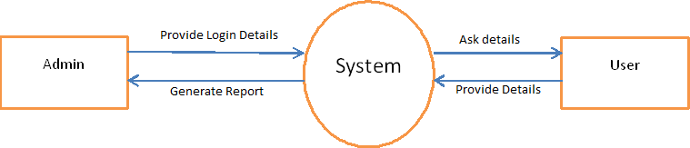

**DFD level 2**

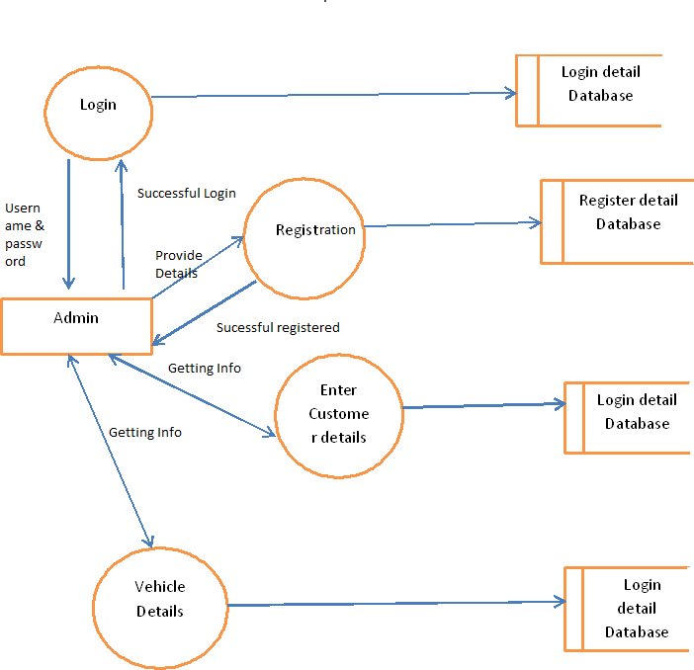

## 6 ER DIAGRAM

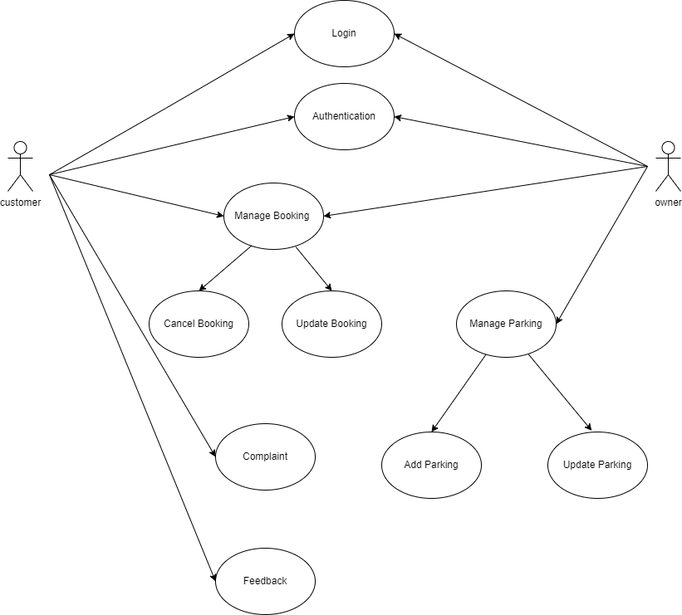

**7. Table Structure**

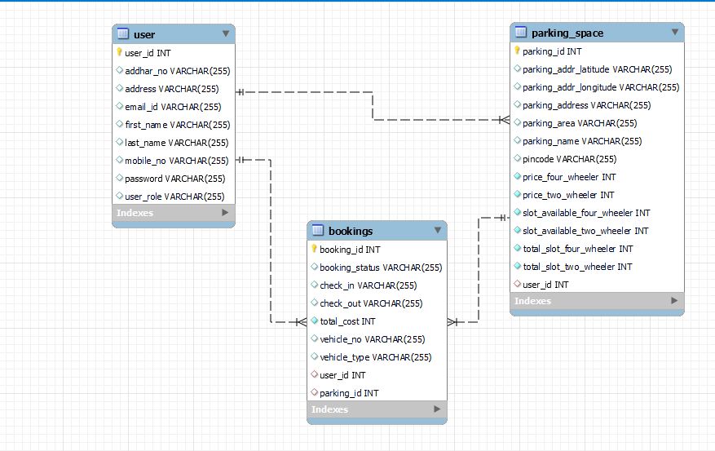

# 8 SNAPSHOT

**Landing Page**

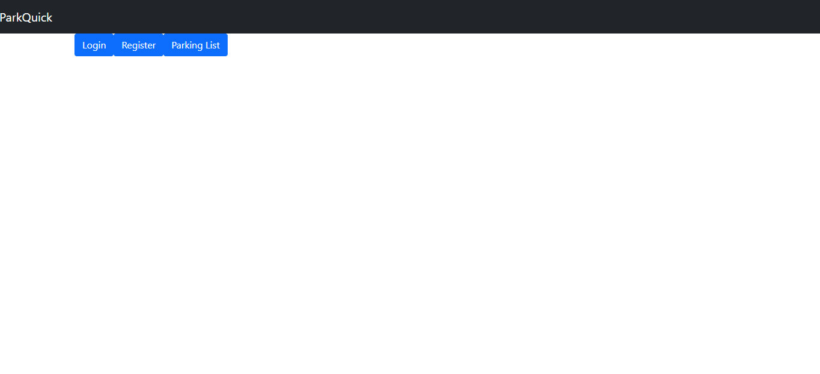

**Login Page**

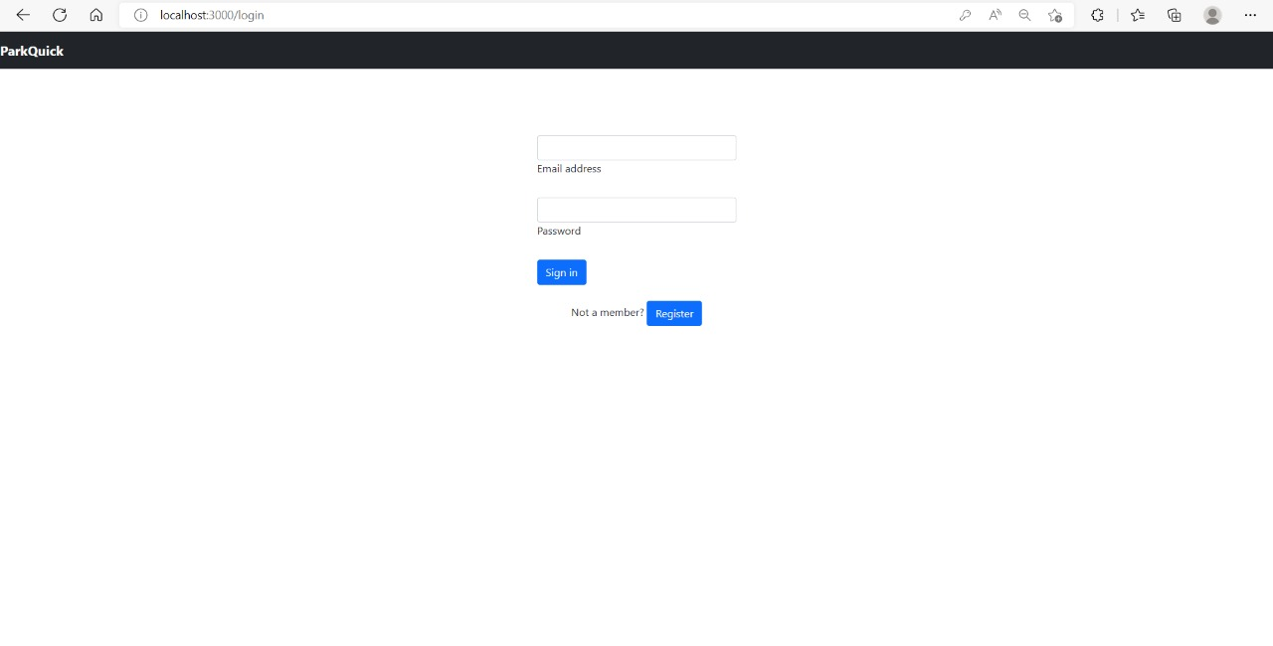

**Resister Page**

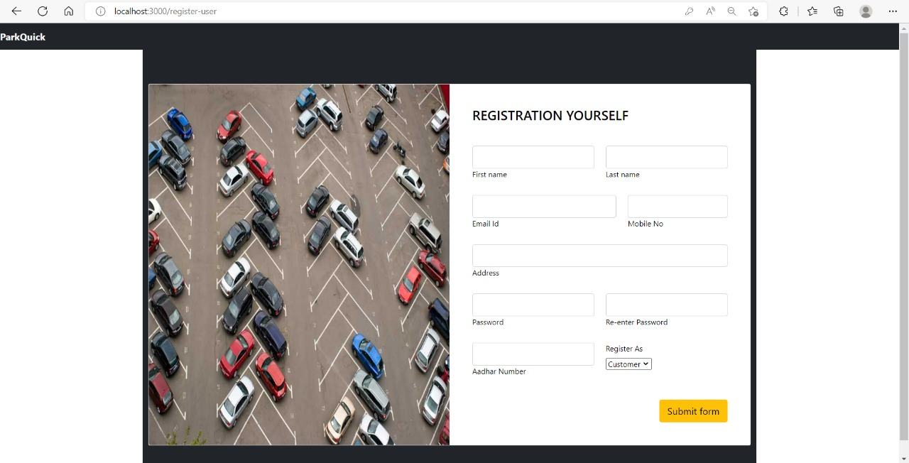

**Parking Book**

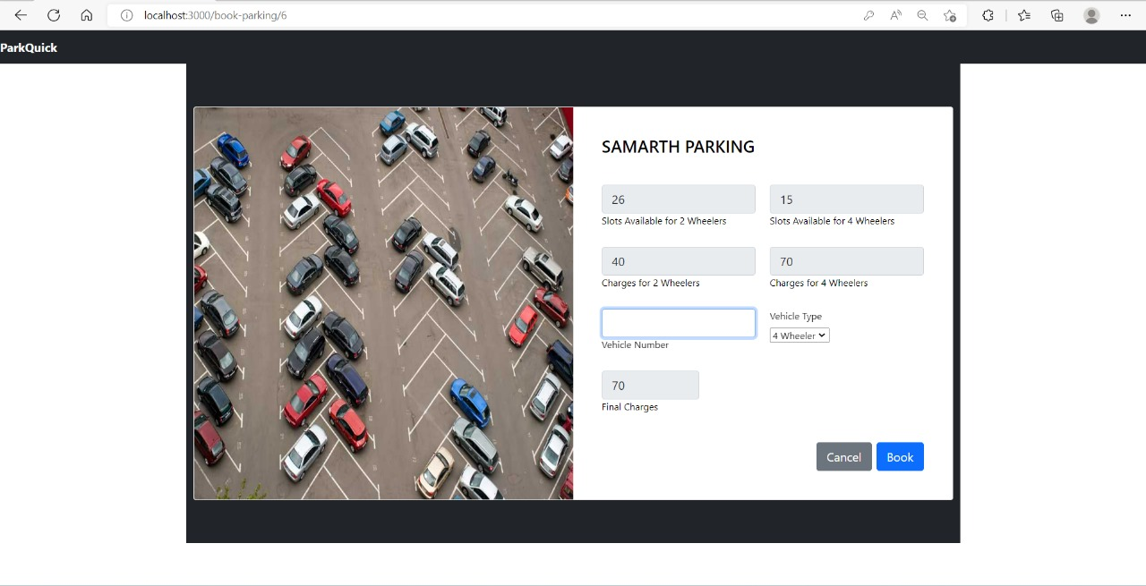

**Parking Space**

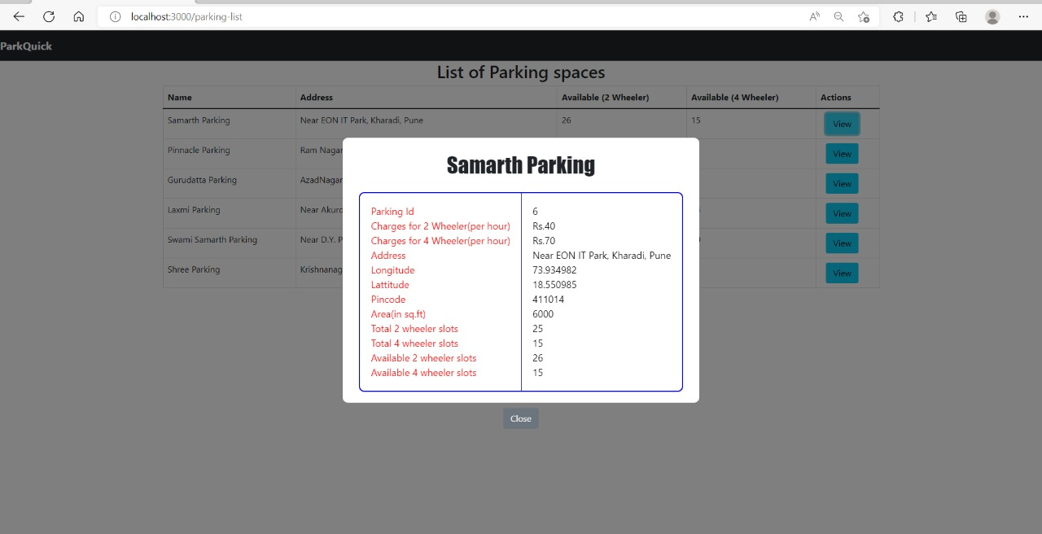

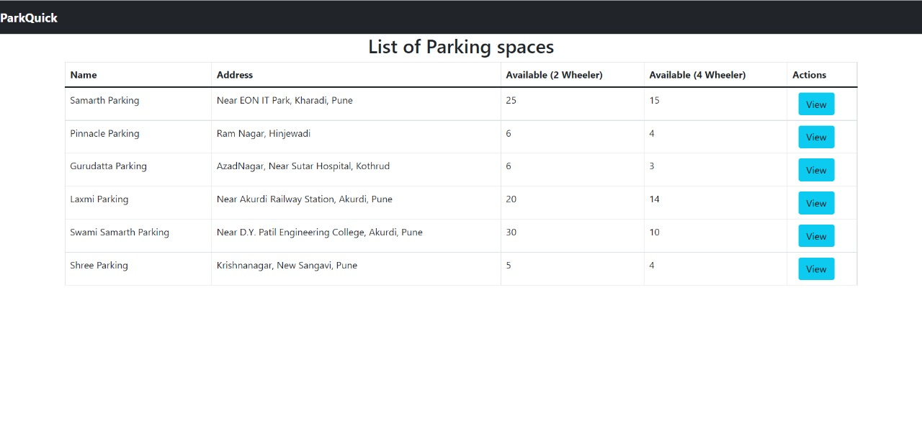

**Booking Modification**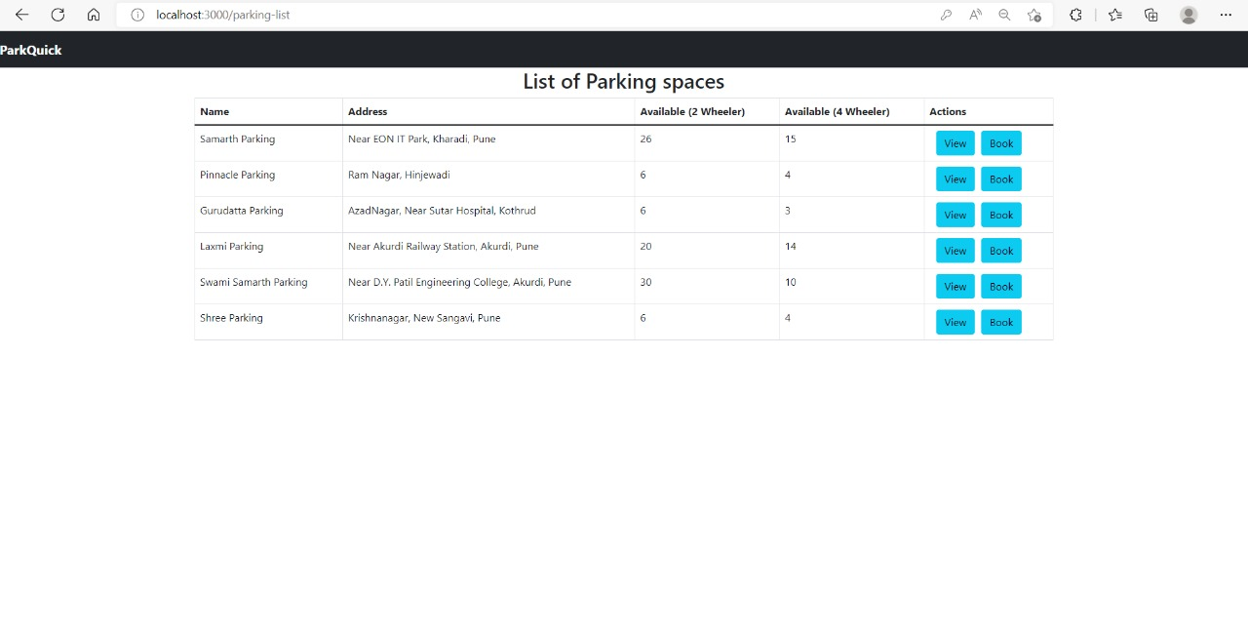

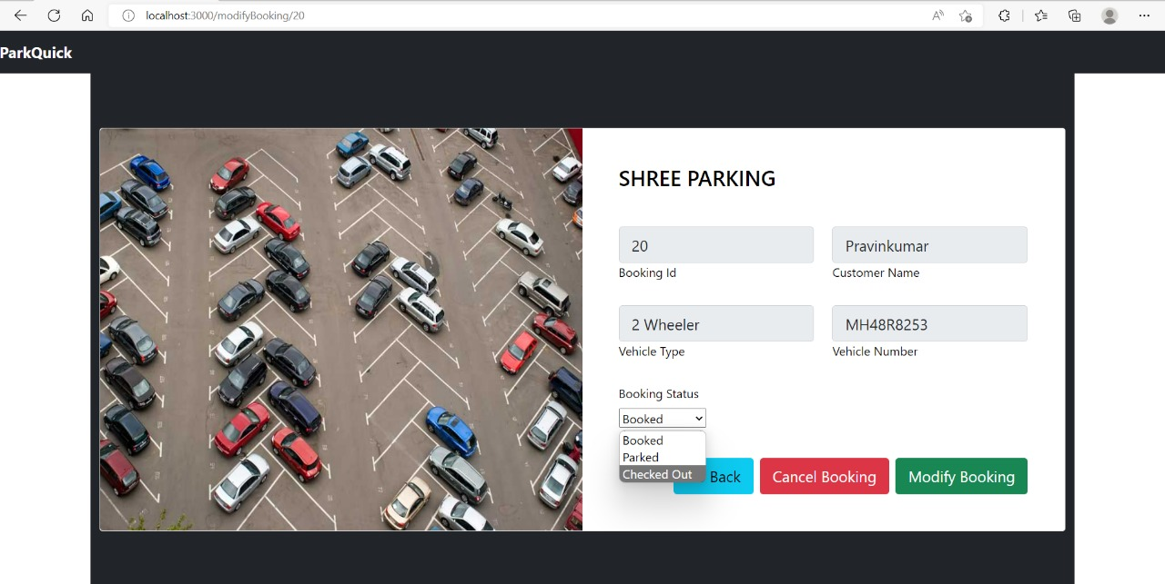

# CONCLUSION

This Project is minimizing the task of parking a vehicle by paying and saying some details about customer and vehicle to save data .In this the vehicle is parked as a safe and secure. This project is done as Efficient as possible

Hereby that the project was completely and slowly developed by me and Group Member . I also conclude that this project has helped us gain more knowledge .I would be glad to enhance and promote this project if given chance and help ourselves and society in the near future

The developed application is tested with sample inputs and outputs obtained in according to the requirement. Even though I have tried our level best to make it a dream project. Due to time constraints I could not add more facilities to it.

The efficiency of the developed system can be enhanced with some minor modifications. Future development can be made in proposed system by integration more services like:

* + It can be implemented through web pages.
  + New effectives modules can be added time to time

#### **10 Future Scopes**

This is the modern age. Many people have vehicles. Vehicle is now a basic need. Every place is under the process of urbanization. There are many corporate offices and shopping centers etc. There are many recreational places where people used to go for refreshment. So, all these places need a parking space where people can park their vehicles safely and easily. Every parking area needs a system that records the detail of vehicles to give the facility. These systems might be computerized or non-computerized. With the help of computerized system we can deliver a good service to customer who wants to park their vehicle into the any organization’s premises.

**Enhancement to create a Bigger and Better System**

These enhancements deal with what would be required in a new improved, bigger and better system

* + In future if when a vehicle enters into the parking area there should be one sensor in which the user can easy identify from outside only Is there parking is full or empty or space is allocated.
  + In future the vehicle can be parked by machines

# REFERENCES

1.W3School.com

2.[www.youtube.com](http://www.youtube.com/)

3. [www.codeproject.com](http://www.codeproject.com/)

4.Javatpoint